**User Interface Specification**

**Introduction**

This document specifies the user interface design for the web application that allows users to input new users and view existing users. The design is based on user requirements and input from stakeholders.

**User Requirements**

* An easy-to-use interface for creating and Viewing users detail.
* A clean and modern design that is visually appealing.

**Design Guidelines**

* The color scheme will be primarily blue and white and gray.
* The table form will be simple and uncluttered to prioritize readability and ease of use
* One the left side of the header of page will display the button to add new users followed by checkbox to hide disable users and on it right side save user button
* On the body of the page the table will be located at the left and a form to input new user on the left of the page.

**Wireframes**

The following wireframes show the proposed design

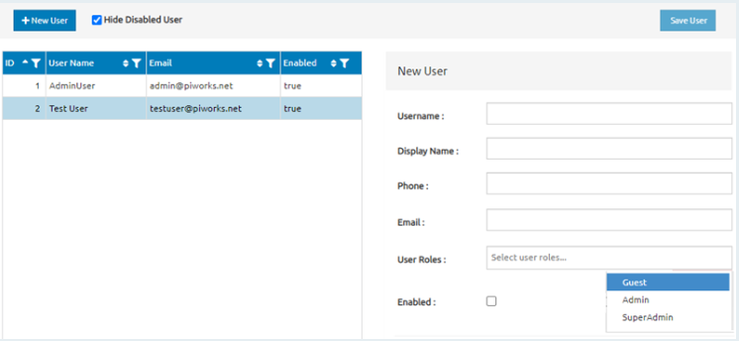

**New user Wireframe**

The new user creation contain a form to fill with a title of 'New user' and a simple form with fields for the username, Display name, phone, email and list of users role either guest, admin or super admin and checkbox of enable.

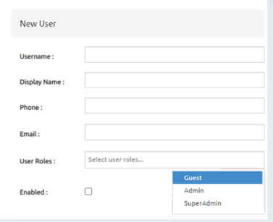

**Conclusion**

The user interface design for has been developed based on user requirements and design guidelines. The proposed design features a clean and modern layout to create and view users information. The wireframes provide a visual representation of the design and will be used as a basis for implementation.